*Curriculum Vitae*

*Rajesh kumar,*

*DevOps Architect and Coach*

Mobile : +91 8105843520(India)

DevOps@RajeshKumar.xyz

SUMMARy

Total, Over 13 years of extensive experience in Software Configuration Management domain having depth knowledge of DevOps, Continuous Integration and Delivery, Configuration Management, Build and Installer, Release Management and Application Management. Performed the various responsibilities in current and past organization e.g DevOps Architect, DevOps Coach & Mentor, DevOps Engineer, Build and Release Engineer, SCM Engineer, Programmer and SCM Administrator.

Have in Depth working experience in following domain with real project implementation.

1. Test Driven DevOps Approach
2. DevOps
3. Continuous Integration
4. Continuous Delivery
5. Continuous Deployment
6. Code Quality and Analysis
7. Test Coverage and Matrix
8. Technical Debt Reduction
9. Cloud Migration using AWS & GC
10. Microservices

My RECENT LOGO

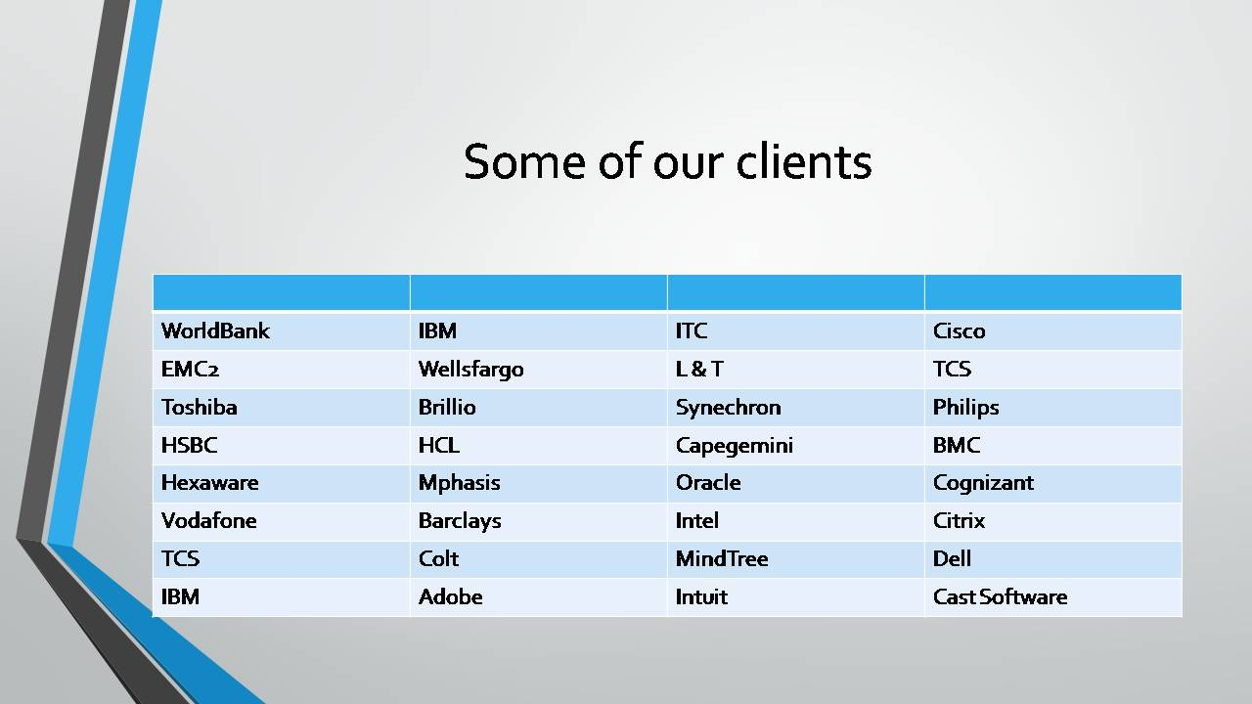

ReviewS & Testimonial

***Youtube***

[***https://www.youtube.com/scmgalaxy***](https://www.youtube.com/scmgalaxy)

***Facebook***

[***https://www.facebook.com/pg/scmgalaxy/reviews/***](https://www.facebook.com/pg/scmgalaxy/reviews/)

***Web***

[***http://www.scmgalaxy.com/testimonials***](http://www.scmgalaxy.com/testimonials)

My Skill SETS

|  |  |
| --- | --- |
|  |  |
| **Languages and Scripting** | **Perl, Ruby, HTML5, Bootstarp, AngularJs, Python, Bash Scripting** |
| **Version Tools** | **Git, Perforce, Github, GitLab, Bitbucket, Gerrit, Subversion and Team Foundation Server** |
| **CI Tools** | **Jenkins, TeamCity, Bamboo, BuildForge, UBuild,** **uDeploy,** **uDeploy and AnthillPro** |
| **Packaging Tools** | Wise Studio, InstallAnywhere and Linux RPM |
| **OS** | **Windows Administration, Ubantu Administration, RHEL Administration** |
| **Build Tools** | **Ant, Maven, MSBuild, Gradle, Gmake, NANT and makefile,** |
| **Config Management** | **Chef, Puppet, Octopus Deploy, Ansible** |
| **Repostory Management** | **Nuget, SonaType Nexus, Artifactory, Archiva, Chocolatey** |
| **Other DevOps Tools** | **Nagios, Jira,** |
| **Monitering Tools** | **Logstash, Elastic Search, Kibana, Microsoft System Center, Stash, Graphite, New Relic** |
| **Cloud & Virtualization** | **Docker, Kubernetes, AWS, VMware WorkStation,** **Vagrant,** **Codenvy VSphere and VirtualBox** |
| **Coverage - Analysis** | **Emma, SonarQube, PMD, Checkstyle, Cobertura, Jacoco and Coverity** |
| **Issues Tracking Tools** | **Jira, Zendesk and ServiceNow** |
| ramework | Eclipse, MVC, Joomla, JQuery |
| App Servers | Apache HTTP, Apache Tomcat, WAMP, XAMP, Jboss, IIS 6.0 |
| Design | Adobe PhotoShop CS 6, Flash CS, CSS, Visio, DreamWeaver CS |
| Databases | MySQL 5, Oracle 9i, PL/SQL |

EXPERIENCES

2016 - 2017

FREELANCER / DevOps Coach, Instructor & Mentor

Currently I am working as a freelancer, DevOps Coach & Mentor to support many organization to implement the DevOps, CI, CD and Test Driven Development Approach

2015 - 2016

SERVICENOW INC, NETHERLANDS / Sr. Build & Release Engineer

I have worked as a Build and Release Engineer in Servicenow, Netherlands, having a responsibility to manage and improve the large and complex build infrastructure which includes 5 Jenkins Servers, 300+ build slaves, SCM and Build servers in Cloud(Gerrit, Maven and AWS). Also involved with build IT infrastructure management and automation using Chef.

2014 - 2015

JDA SOFTWARE, INDIA / Sr. DevOps Architect

Worked as a DevOps Architect in JDA Software to implement Continuous Integration and Delivery model and streamline the build and release process for 130 products. Also work on to standardization the different tools and processes within organization. Tools includes Git(Gitlab), Redhat Linux, Bash Scripting, Artifactory, Maven, Puppet and Jenkins.

2013 - 2014

INTUIT INC, INDIA / Sr. SCM Engineer

Worked as a Sr SCM engineer to implement CI/CD for a business unit called “Small Business group” in Intuit which has many products including QuickBooks Online(Java), Desktop(.net), Android, POS and Camps. SCM infrastructure has many tools and technologies such as Jenkins, Chef, Maven, Nexus, Perforce, and Git(GitLab) in Linux and Windows Environment.

2011 - 2013

ADOBE SYSTEMS, INDIA / Sr. SCM Engineer

Worked as a Senior SCM Engineer in a Global team of 4 members , responsible for handling 15 Perforce servers which has more than 150 perforce instance, 150+ proxy and 4000+ users and 10 Terabytes of source code. I was also responsible to handle 30+ Continuous integration build forge servers. We were also handling 35+ RedHat Linux Machine for our build & release serer infrastructure. Supporting Development teams are located in Seattle, Minnesota, Canada, Ireland, England, Germany, Japan, and India. Adobe SCM environments includes Perforce, Git(Github), Jenkins, Build Forge, Perl script in Linux and Windows Environment.

2010 - 2011

IBM CORPORATION, INDIA / Sr. Build & Release Engineer

Emptoris Services Procurement(IBM Product) delivers transparency into an organization’s services spend, demand and procurement process. Being a part of Global Build and Release team, responsible for managing and support end to Build and Release activity, SCM server management and automation. SCM environments includes the tools such as Ant, Perforce, Redhat Linux, Shell Scripting, Jira, Emma, Sonar, Hudson.

2009 - 2010

NESS TECHNOLOGY, INDIA / Sr. Build & Release Engineer

Chordaint Foundation Server is a set of distributed component that work together to provide an execution environment for eBusiness applications. I was acting as an individual contributors to support end to end SCM, build and release cycles which has Environment had a tools such as Subversion, Bamboo, Maven, Ant, Solaris, Shell Scripting, Jira, FishEye, Crucible, Clover, Crowd, Sonar. Supporting team for Build & Release requirement & Responsible for daily build Plan configuration and New Project Setup in Bamboo and Debugging, Maven script changes according to branch/release specification, Helping team in Release Activity (Code Completion, Code Freeze, Branching, Tagging and Release of Build), Build Server and CM server management, plugins integration, upgrade and maintenance.

2006 - 2009

MINDTREE LTD, INDIA / Sr. Build & Release Engineer

This was one of the great phase for learning and implementing the automation in Build and Release environment. During this tenure not only, I supported the 6 different projects but also performed the build and release automation from scratch. I worked with many of the tools which includes, MKS Integrity, Perforce, Ant, Suse Linux, AnthillPro, Gforge, InstallAnywhere and Tomcat, Shell Scripting, Batch Scripting, Wise Studio, Continuum and Gforge, Subversion, RPM, RedHat Linux and CruiseControl

2005-2006

ACCENTURE PLC, INDIA / Software Engineer

Worked as Configuration and package Engineer in Unix Environment. Worked in Project and Configuration Management. Set up Defects and Features for DDS, create packages and Install into Servers, wrote PL/SQL and Shell scripting to run on the server and Configure Software life cycle management for Different Releases Using Internal tools.

2004 - 2005

SURGERYPLANET, INDIA / Software Programmer

I worked as a programmer developing the SurgeryPlanet.com. I was one of the first programmer for SurgeryPlanet.com who started the coding and bring the portal into the Shape. I have working on PHP, MySQL, Joomla, CSS, HTML, JavaScript, Core Java, Maven, SVN in Windows and Linux Environment.

VISA SUMMARY

* High Skilled Visa for Netherlands
* Business Visa for USA
* Business Visa for UK

SOCIAL

***Linkedin Profile***

[***https://www.linkedin.com/in/rajeshkumarin***](https://www.linkedin.com/in/rajeshkumarin)

***Facebook Profile***

[***https://www.facebook.com/RajeshKumarLog***](https://www.facebook.com/RajeshKumarLog)

***Twitter Profile***

[***http://twitter.com/rajeshkumarin***](http://twitter.com/rajeshkumarin)

EDUCATION

* **Master in Technology (M.Tech) - (Software System)**
* **Master in Science (M.Sc) - (Information Technology)**
* **Bachelor of Information Technology**